Form type:

Tree.st / MIT

Report submission date: 10/20/2012

Author information

Name: Omid Sadeghpour Email: omid@mit.edu
Address: 17A Bigelow St. Cambridge, MA 02139
Phone number: 510-499-5497

Are you applying as an individual or on behalf of a group? Individual
If applying on behalf of a group, which one?
Indicate your role at MIT and/or your group:
Indicate your role at MIT and/or your group:

List any additional organizers/contacts:
Shailesh Mittal shailesh@MIT.EDU
Alexander Romanov aromanov@MIT.EDU
Adam Borelli aborelli@MIT.EDU

Account information (required)

MIT account number: N/A - applying as individuals
Account supervisor:

Note: By December we should be able to get you an account number

Other information

Project duration: 12/01/2012 to Ongoing…

Requested funding amount: $15,000
Please answer the following questions (in bold) and also address the subpoints.

1. Please describe the new service or activity you are proposing.

Finding other graduate students at MIT is hard. For example, when I first arrived at MIT I could not easily find all the other graduate students from Ecuador interested in Agricultural Bioengineering, let alone finding other graduate students from Ecuador.

As a result I created Tree.st/MIT – this online tool allows MIT graduate students to easily and fluidly search for one another. Specifically, this tool will allow graduate students to:
- Voluntarily provide their information to a MIT-specific community search engine (Appendix A)
- Find other students by specifying the very specific qualities or attributes of people the graduate student is looking for (Appendix B)
- Automatically group new students in “Smart Groups” – these are groups that are dynamically generate and are recalculated 24/7 (Appendix C)
- Communicate with all the members of a smart group to organize events, dinners, functions and to foster united graduate community (Appendix D)
We piloted Tree at MIT Sloan (www.tree.st/MITSloan) and within the first two weeks of school, 400+ graduate students joined and began connecting with their peers, enabling a level of information sharing never before seen at MIT Sloan.

As we market Tree across MIT we plan to host 100-200 “Tea & Cookie” social functions. These Tea & Cookie socials will each have very specific themes, for example:
- Mechanical engineers and software developers interested in 3D-printing
- Gluten-Free students
- Students interested in China and wind-based alternative energies
- Stressed students looking for support buddies with similar ethnic backgrounds
In essence, the service and activity we are proposing is composed of an online tool and 100s of face-to-face social functions across MIT. The purpose of the face-to-face socials is to introduce graduate students to each other in an effort to break departmental silos and to engender a new level of collaboration focused on:
- Help graduate students improve their quality of life while at MIT
- Introduce focused, scientifically interdisciplinary, and meaningful topics among thematically designed graduate student groups

2. How does your project foster graduate community?

After interviewing 60 graduate students the number one complaint we kept identifying was that MIT has departmental silos. These silos make it practically impossible for graduate students to easily find one other, and to have inter-disciplinary conversations.

Tree fosters the graduate community by presenting students with an innovative online platform (different from Facebook and LinkedIn) which allows them to search for their peers at MIT using MIT-specific attributes not found in other social media sites. For example, graduate students could easily find other students with similar research topics, experience, dietary restrictions, hobbies, academic interests, preferred sports, living location, and/or other specific criteria.

In a secure, private, and spam-free manner Tree allows for graduate students to easily find other students across MIT, knitting the school together.

The second aspect of our application is creating about 100 “Tea & Cookie” social events across campus. These face-to-face socials are meant to introduce graduate students with similar interests with one another in an effort to create new bonds of friendship. These small social gatherings will inevitably improve the graduate student community since it will:
- Create inter-departmental, inter-program, and inter-disciplinary bonds of friendship in the graduate student population
- Allow a space for dialogue about very specific topics graduate students (and/or their significant others) currently have no place to share
- Allow for newly admitted students to, year after year, easily connect with the MIT community as they are automatically added to “Smart Groups” on Tree and consequently invited to the Tea & Cookie socials

Desired outcomes:
One of our desired outcome is to have several thousand MIT graduate students join Tree.st/MIT. Our goal is to have at least 70% of the graduate body join the site, create profiles, and start finding peers through the site’s unique search engine. As we market Tree.st/MIT we also plan to host about 100 “Tea & Cookie” functions.

Through these very specifically themed social functions we expect to create a level of dialogue that leads to (1) actionable improvements in the quality of life of the graduate students, (2) a sense of belonging for the new students, and (3) most importantly, a new level of inter-departmental collaboration and knowledge exchange.

3. Why do you consider this project feasible?

The website/online platform has already been developed. We believe that it is feasible to build a user base of several thousand MIT students, and to bring them together by hosting events that will focus on specific themes. Since there is currently no effective way to do this at MIT, and since we have heard from many graduate students the need for such a tool, we expect deploying this tool across MIT to be feasible.

Tree has already been tested with 400+ MIT Sloan students who are actively using the site. We have been asked by MIT-wide graduate students to make the service available to the whole campus, but we require your help to make the marketing and the social functions a reality. Marketing this tool, and hosting hundreds of Tea & Cookie nights is a very manageable task to do – we just need resources to carry it forward.

Plan for implementation:

The website has already been designed and is currently active and usable by students. Please refer to “publicity plan” below. For the Tea & Cookie nights, besides ourselves, we plan to find and train ambassadors across MIT that would be interested in hosting these events. We already have 2-3 graduate students interested in hosting these events across MIT. Post grant, we plan to recruit 5-10 more volunteers, each of which we will ask to host 10-20 Tea & Cookie functions throughout Spring semester.

Timeline of planning and activities (as specific as possible):

We plan to start sending e-mails out to MIT graduate students promoting the platform in late-November. Then towards the beginning of December, we plan to recruit students from various departments and schools within MIT to be Tree.st Tea & Cookie “Ambassadors” within their departments/schools. Starting Spring semester we plan a large marketing campaign across MIT, by March we expect at least a few thousand graduate students to have joined Tree and to have participated in the themed Tea & Cookie socials.

Licenses required for proposal: N/A

Liquor
Entertainment
Movie rights
Other – please explain:

Liability issues for your proposal:

There are little to no expected liabilities arising from this proposal. We are simply promoting an innovative new collaboration tool for students within the MIT community. As for the hot water and coffee associated with the Tea & Cookie socials, we plan to purchase 2-3 secure water heaters for tea, and the cookies or assortment of pastries will have to be specific to the group (i.e.: cookies for the gluten-free social will have to be gluten-free)

Publicity plan:
We plan to publicize the online tool through e-mails to all students at MIT as well as with help from the MIT admissions office to promote this tool amongst incoming graduate students. We also plan to place posters, flyers, and other marketing materials.

4. What impact will this project have? Describe your desired outcomes for an enhanced graduate experience.

Tree will enable thousands of graduate students at MIT to search for and connect with peers across departments and schools – departments which currently have a “silo” effect to them as described by interviewed graduate students. Our desired outcomes are to enable the creation of new friendships among the graduate student population, and most importantly, to host face-to-face events that are themed and whose dialogue is action oriented.

Plan for evaluation of impact (qualitative and/or quantitative):

We plan to evaluate the impact of Tree.st/MIT by:
- Counting the user base of graduate students on the site by March 2013
- By counting the number of “connections” the graduate students created online, and determining whether or not these are inter-departmental connections
- By sending out quick surveys to each student who signs up for the Tea & Cookie socials and asking them if they made meaningful connections with their peers at MIT.
- We plan to generate social graph to visualize the types of connections we notice at the social events and on the website (Appendix F). These will be useful in proving that Tree and the Tea & Cookie nights have create thousands of bonds of friendship which otherwise would have never have occurred

What will it take for your project to be deemed successful? How will you know if you accomplish your objectives?

In order for Tree to be a successful collaboration tool, a strong user base of MIT students needs to be built, both at the undergraduate and graduate level. This needs to be done through aggressive publicity including e-mail, word of mouth, and Tea & Cookie socials. This objective will be accomplished when at least 70% of graduate students, research assistants, professors, and administrative staff, all within the MIT community join Tree and start searching for people that will matter to them.

For the Tea & Cookie socials we hope to survey around 80% of all Tea & Cookie participants, from these surveys we expect a 80% satisfaction on the “quality of dialogue” engendered at the social event. Two months post the social event we expect each participant (of the 80% covered in the survey) to document they met and regularly hang out with 2 other graduate students they met through the Tea & Cookie socials. Since the themes of the Tea & Cookie socials will be very specific, inter-departmental, and are action oriented, we expect such bonds of friendship to inevitably change and improve the quality of life of most graduate students at MIT.

5. Where did you first learn about the Graduate Student Life Grants?

“MIT GSC ANNO” newsletter from Bomy Lee on October 1st.

6. Please also attach a copy of your proposed budget; a sample budget and optional template are provided. Any other supporting materials may also be included.

7. By submitting this proposal, I promise to keep in contact with Grants staff, and submit an annual progress report by the requested date while my project is supported by GSLG funds.

Please note that no events will be funded that are to occur less than two weeks after the final GSLG funding announcement.

Thank you for your submission!

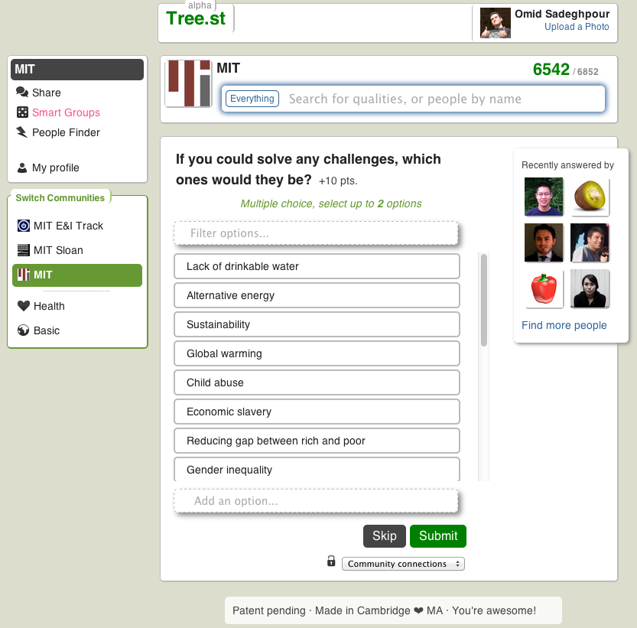
Appendix A – Information gathering
A

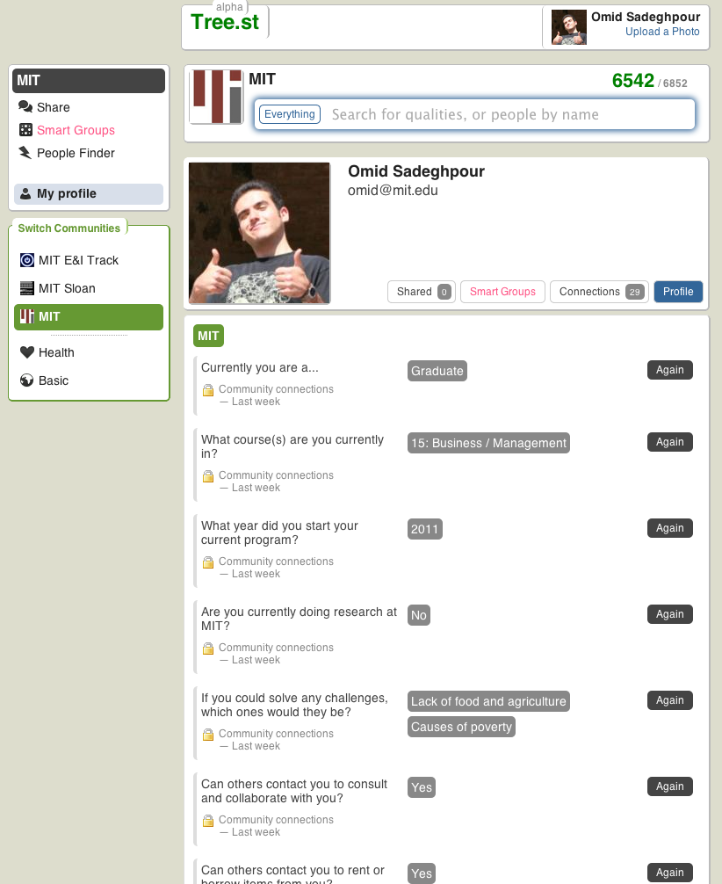
1b1
1b1
1b1
1b1
1b1
1b1
A
B
C

Appendix B – Search for others
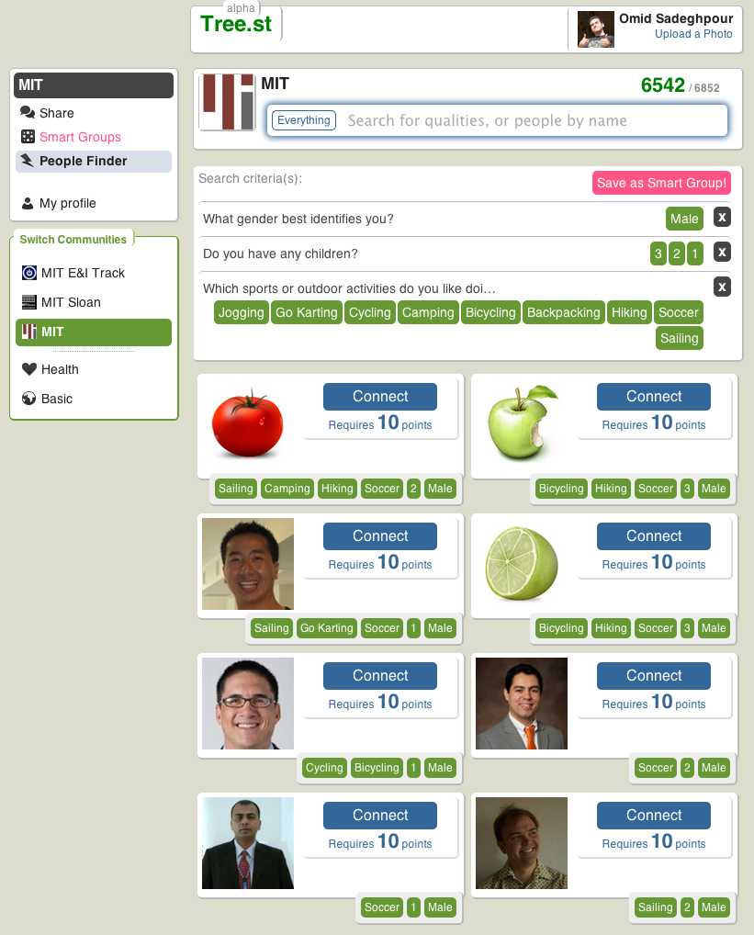
A
B
C

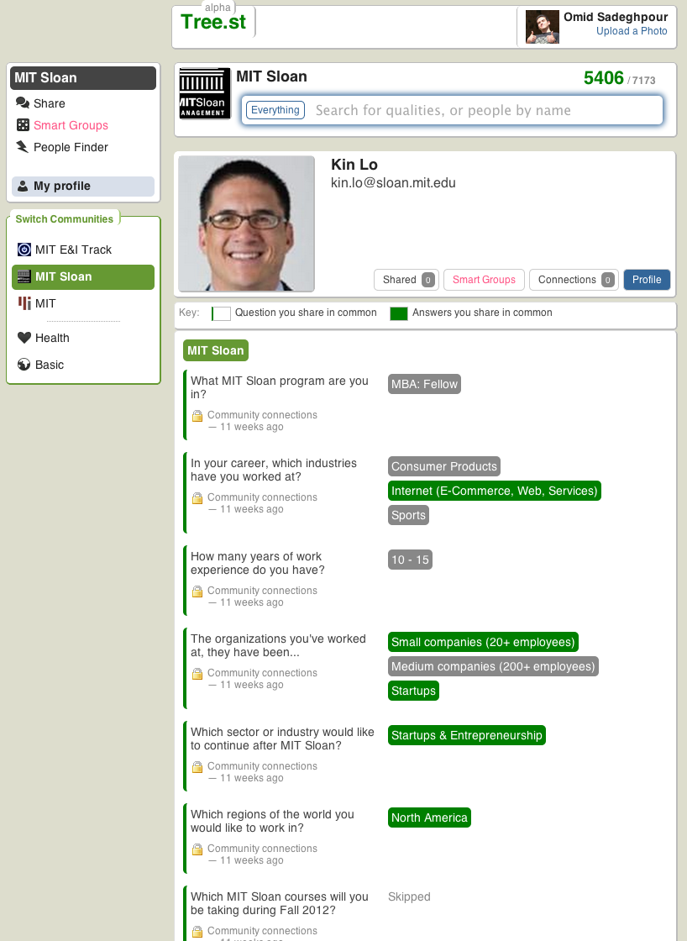
A
Appendix C – Smart Groups

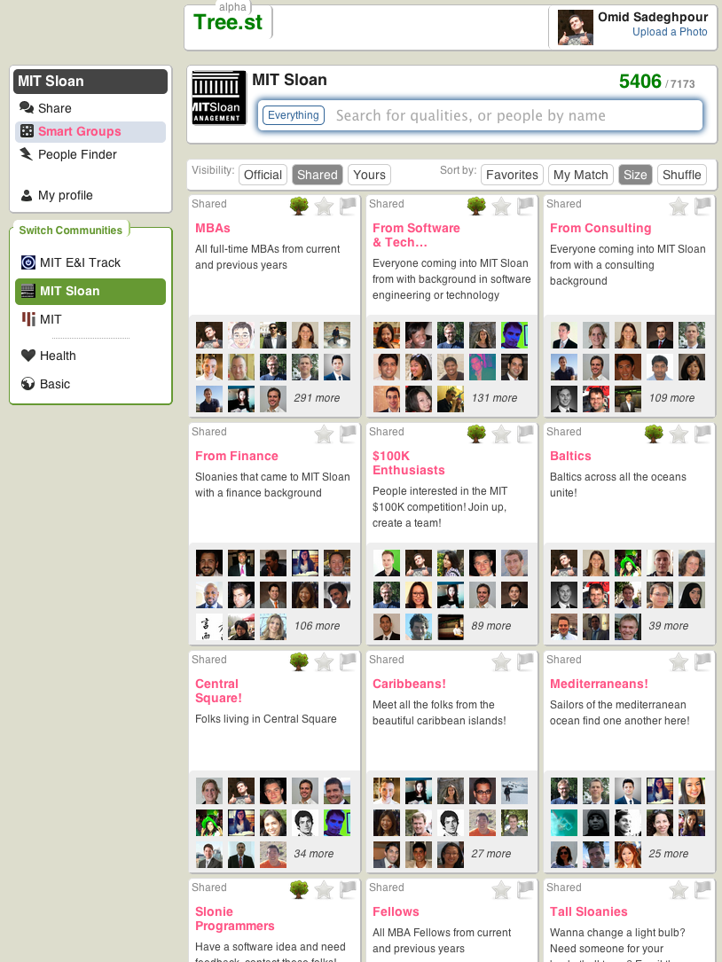
A
B

Appendix D – Communication platform
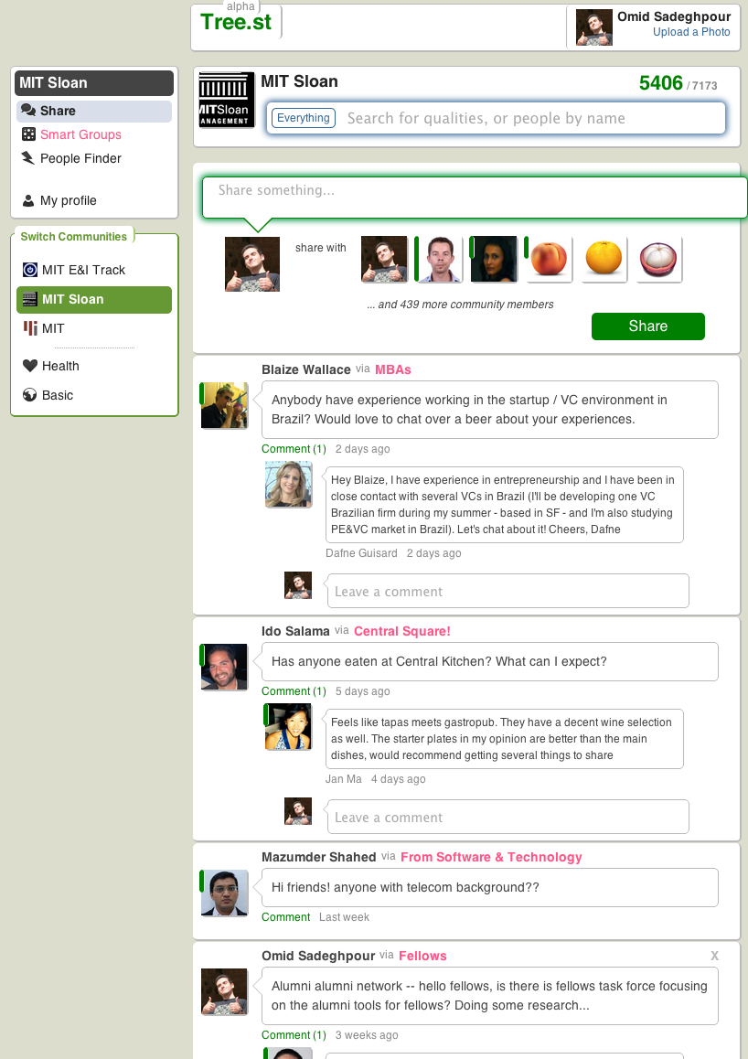

A

B

Appendix E – Social graphs
